Supplementary Appendix 4. Decision Curves and Development History
Decision curves, final model
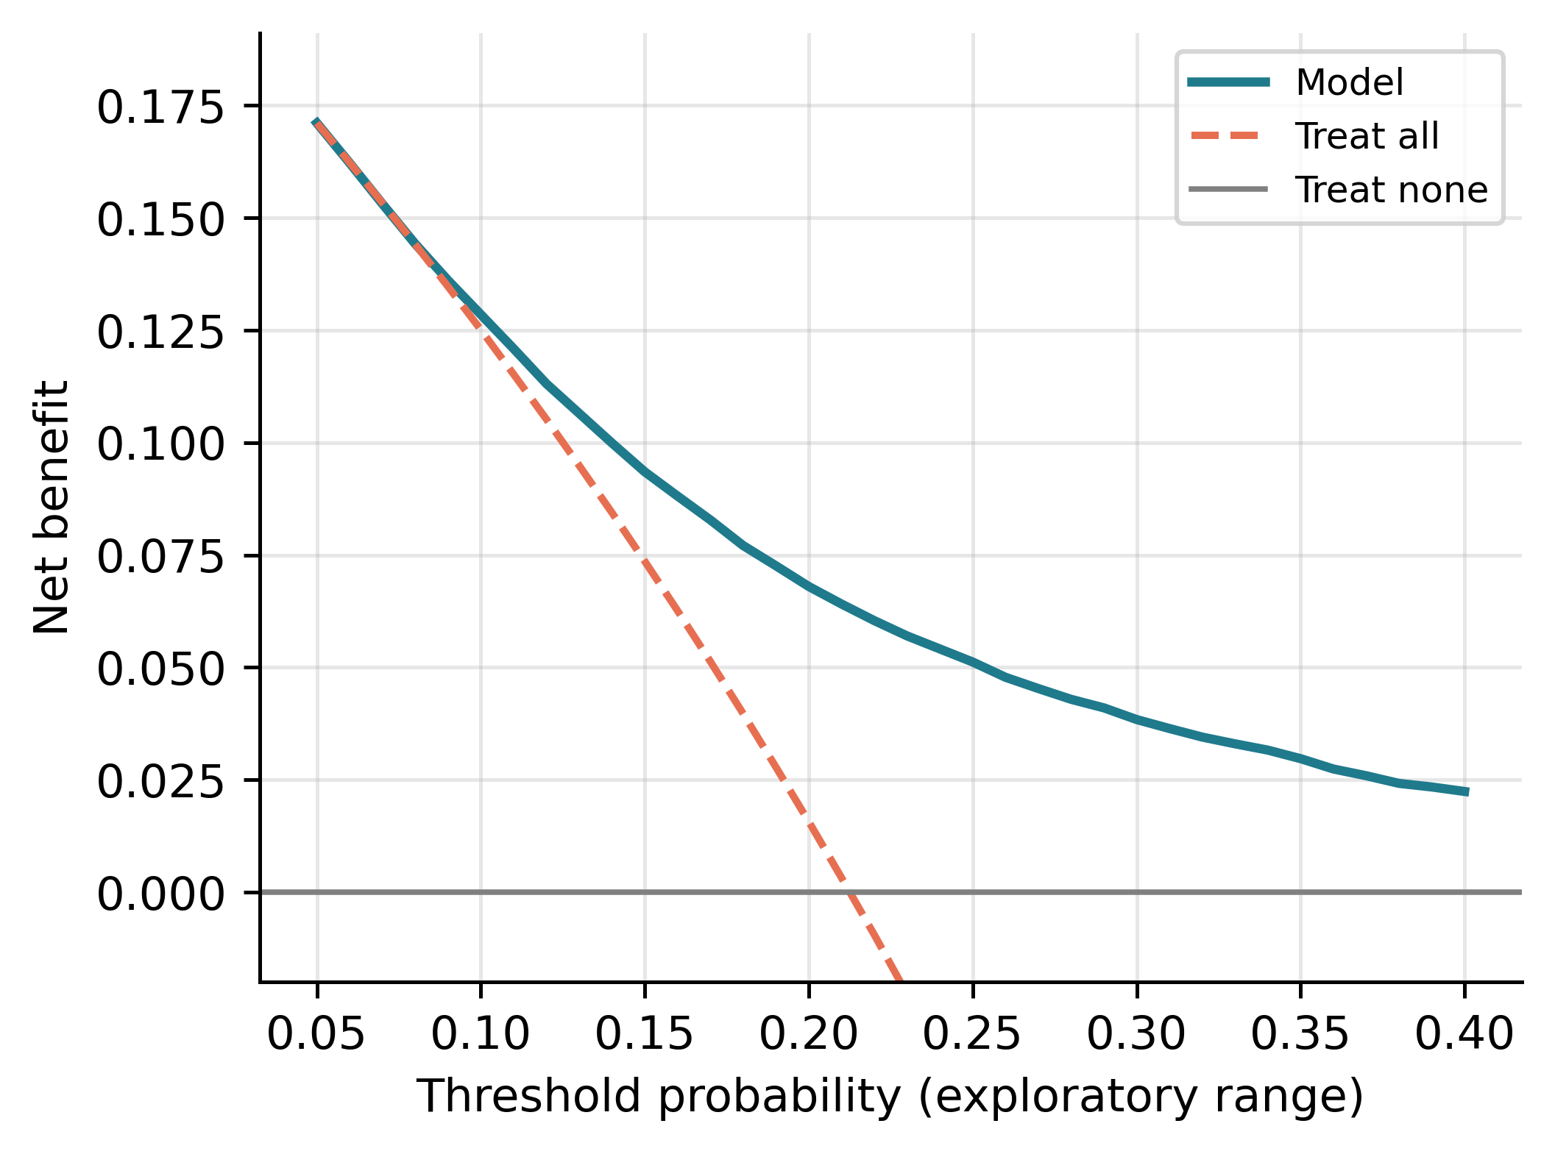
Development history
Earlier versions of this pipeline, including all versions released before October 2026, contained a 180-day length-of-stay trend feature (and two interaction terms built from it) later shown to encode the patient's later admissions. Their performance figures are therefore inflated and are listed only as history.
Version | Result | Status
Capstone feature tables V1 to V7 (LightGBM) | 0.7051 to 0.7934 | Contained billing features and leaked variables
Four boosting families, 10 seeds | 0.7935 to 0.7970 | Pre-correction cohort; leaked variables
Corrected cohort, 66-feature model | test 0.7800 | Billing features and leaked variables
v5/v6 consensus model (31 features) | out of fold 0.7748; test 0.7738 | Contained the leaked trend feature; superseded
v7 to v10 consensus model without the trend features (47 features) | out of fold 0.7058; test 0.7064 | Used a source table with global median imputation; superseded
v11 consensus model (48 features) on the table rebuilt without global imputation | out of fold 0.7058; test 0.7060 | Superseded
v12 consensus model (48 features); discharge cutoff on laboratory and medication counts; two duplicate pool features dropped | out of fold 0.7057; test 0.7055 | Superseded
v13 consensus model (44 features); documentation-time cutoff on chart, medication-administration, and prescription features; discharge interval from any earlier admission | out of fold 0.7057; test 0.7056 | Reported model
Race-encoding ablation (earlier model, validation partition) | 0.7954 with vs 0.7949 without | Race encoding excluded throughout

